**[Client's Name]**  
[Client's Title]  
[Client's Company Name]  
[Client's Address]  
[City, State, ZIP Code]

[Date]

Dear [Client's Name],

Thank you for the opportunity to partner on your building project. At [Your Company Name], we believe transparency is the cornerstone of a successful partnership.

In the spirit of our commitment to transparency, here is an example of a Gordian price proposal. Designed like an itemized receipt, it clearly outlines the costs of your project and helps simplify the approval process by providing:

* **Detailed cost breakdowns** to show exactly what you’re paying for.
* **Clear communication** to build trust and avoid surprises.
* **Streamlined workflows** to get your project moving quicker.

We’re confident that this approach will not only meet but exceed your expectations for clarity and professionalism so you have complete confidence in our process.

If you’re ready to get started today, give us a call, contact us at INSERT EMAIL HERE or provide a little information using the QR code below. We look forward to working with you to bring your projects to life.

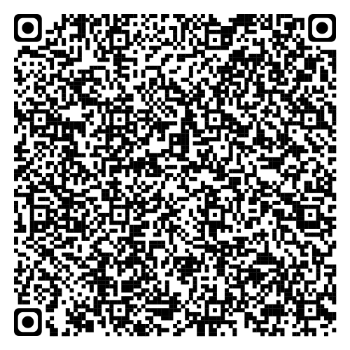

Sincerely,  
[Your Name]  
[Your Title]  
[Your Company Name]  
[Your Contact Information]